Registration Information

Name: _____________________

Phone: ____________________

Email______________________

Dietary restrictions: ____________

__________________________

I/We would appreciate:

- Childcare ________
- Transportation ________

A suggested donation of $10 per person would be appreciated when registering. There will be no other cost to participants.

Please cut off this Registration form and hand in registrations to Tom Sellers during Coffee Hour or submit to Parish Office c/o Tom Sellers

Retreat Schedule

10.00 Coffee, Introductions, opening prayer (Paul Friesen)

10.15 David Dean’s First talk: “What is Lent?'' with Q & A

11.00 Walking & Talking

12.00 Noon Prayers with Taizé-Celtic music (Andrew Killawee)

12.20 Lunch & Conversation

1.00 David Dean’s Second talk: “Living in Lent?” with Q & A

1.55 Closing Prayers

Assisting with the Retreat

If you are planning to be present, and feel you could assist with retreat details on the day of the retreat, such as setting up the food and drinks that will be delivered, would you let Tom Sellers know? He will relay your offer to the Spiritual Development Committee.

Why bother with Lent?

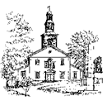

St. Paul’s Church, Halifax
Parish Retreat
Saturday 21 February
10 am – 2 pm

Location: Chapel Building,
Atlantic School of Theology (AST)
660 Francklyn Street, Halifax
(off Pine Hill Drive, which is off Tower Road)
Parking on Francklyn Street
and in AST parking lots.

About the Retreat

The Spiritual Development Committee of St. Paul’s Church, Halifax, warmly invites you, and your family and friends to a mini-Retreat, on the first Saturday after Ash Wednesday. It’s a way into a season that has spiritually refreshed Christians at St. Paul’s and elsewhere over the generations. St. Paul’s Church has tried various forms of retreats over the past decades; we hope this year’s also gives food for thought, in a quiet place with church friends and neighbours.

St. Paul’s congregation is offered a mini-Retreat this year which features two talks by/conversations with David Deane about the Christian origins of Lent and how we might enter this experience in a healthy spirit this Lent; Celtic/Taizé noon prayers; lunch; and time to talk and walk in Point Pleasant Park or along the North-West Arm.

Our speaker, David Deane, received his Ph.D. in Theology from Trinity College, University of Dublin. He teaches theology at the Atlantic School of Theology, Halifax, and publishes scholarly and popular books and articles on theology and ethics in the contemporary world.
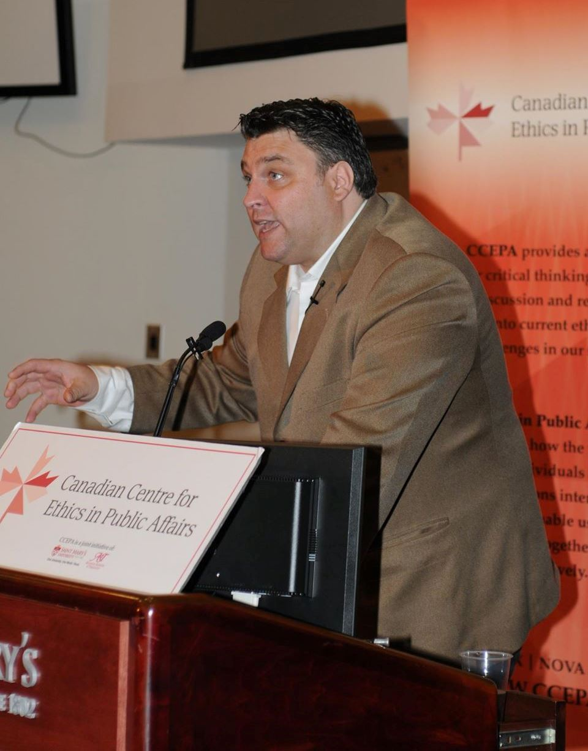

David is a layman who loves Jesus Christ and has a love for the church. He has offered homilies at St. Paul’s on a number of occasions and made many presentations to church groups in Nova Scotia. In addition to his teaching at AST David is the director of the MA program and the diploma program in the New Evangelization, and serves on the board of the Canadian Centre for Ethics in Public Affairs. He lives in Dartmouth with his wife Jennifer and daughters, Sophia (8), Chora (6), and Áine (20 months).

Thoughts from David Deane

A few comments on his talks:

“I am thrilled to be joining you at your upcoming retreat. During it I hope we can discuss how Lenten practices can help shape our selves in response to God’s love.”

“Indeed, if you let me, I will try to persuade you that spiritual practices, especially those common to the Lenten season, represent ‘revolutionary activities’ aimed at liberating our desires from consumerism.”

David Dean’s reply to our invitation:

“I have always been so grateful to you and to God for the welcome that I, like many other “strangers”, receive at St Paul’s and I really am honoured and blessed to be invited to share this time with you on February 21st.”

